Cyber Monday Deal

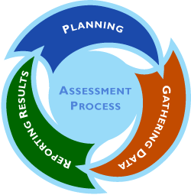

For Centers:
- One Program Administration Scale (PAS) to measure the leadership and management practices of your program.
- One Classroom Assessment Scoring System (CLASS) to look at classroom interactions and improve the effectiveness of teacher-child interactions
- One Environmental Rating Scale (ITERS, ECERS or SACERS) to identify strategies for improving the quality of care in your learning environment

This bundle includes pre-and-post observation preparation, 3 hours of direct classroom observation for one classroom, scoring and review/feedback of results and scores with Center staff by a reliable CCRC staff. All necessary materials will be supplied by the CCRC. The CCRC will also help with development of an action plan if requested.

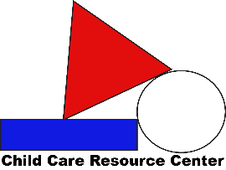
If you contracted with us for each assessment separately the total cost would be $480, or $160 each. As a bundle of three, we are able to offer you one assessment for FREE so that your total cost is $320.

