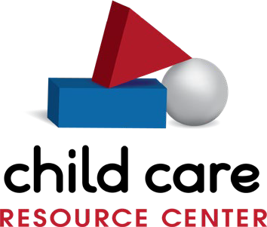
Family and Community Engagement Specialist

Responsible To: | Director of Program Innovation  The Family and Community Engagement Specialist will recruit families and support providers, families, and the community by providing; parent cafés, resources, referral services, parent training, parent advocate home visits, provider updates and technical assistance to their caseload of child care providers around parent engagement and parent & community consumer education.
Purpose of Job:
Qualifications: | - Bachelor’s Degree in early care and education or closely related field preferred with a minimum of 2 years’ experience in early care and education  - Ability to coordinate/conduct small group sessions  - Knowledge of parent engagement planning and implementation  - Ability to collect, compile, and analyze data  - Ability to work independently as well as a team leader and team member  - Excellent communication and organization skills including social media and blogging
Key Areas of Responsibility: | - Recruit families and identify opportunities to reach families with resources related to:  - High-quality early care and education settings – SUTQ, Accreditation, etc.  - Locating early education programs to meet family and children’s needs  - Potential foster/adoptive caregivers  - Protective Factors including Parent Cafés and Concrete Supports  - Fully implement the CCRC mission through a caseload model of service delivery and meaningful relationships.  - Maintain an accurate database (Work Life Systems) of all providers on your caseload within the CCRC service delivery area. Must ensure provider updates are completed every six months.  - Refer families to providers in database and contact parents to verify program effectiveness, questions or additional information. Referrals are emailed, mailed or provided over the phone.  - Provide Parent Advocate Home Visits that empowering the parent through:  - Parent-child relationships; home-school relationships; co-coordinator-parent relationships; and parent-parent/ community relationships  - Educating parents re: children’s physical and emotional development and realistic expectations of child behavior  - Role-modeling appropriate parenting techniques including positive communication, listening and age-appropriate limit setting and discipline  - Enhancement of home-management skills such as, budgeting, organization and nutrition  - Support in times of crisis  - Provide services to families related to agency grants or projects (i.e. strengthening families, Parent Café’s, Parenting Wisely, Triple P, Foster Families, Trainings etc.)  - Help educate families, and community organizations on child development issues, nutrition, and other CCRC services through outreach, consultation, meetings, and newsletters.  - Contribute to leadership in the community concerning advocacy for quality child care.  - Represent the agency at various meetings as assigned.  - Assume other responsibilities as assigned by supervisor.  - Identify innovative strategies to continuously challenge all CCRC team members to make 212 degrees their personal target.

Benefits:

Fulltime position
- Benefits: Medical (CCRC pays 70%), Life
(paid by employer), 403b Retirement, Sick Leave, Vacation Time
Core Values:

Every Interaction Matters – RELATIONSHIPS Committed to expanding and sharing KNOWLEDGE INNOVATIVE in serving our community INTEGRITY in our daily interactions

TRUST earned with every action

CCRC is an Equal Opportunity Employer. All qualified applicants will receive consideration for employment without regard to race, color, religion, sex, gender identity, sexual orientation, age, national origin, protected veteran status, disability, or any other basis protected by federal, state, or local law.

