General Position Description
The Substitute Teacher provides backup teaching services for a variety of child care centers throughout Lorain County. Children in the centers have ages ranging from 6 weeks to 12 years. The Substitute Teacher creates and maintains a respectful classroom culture that fosters safe and productive learning. The Substitute Teacher monitors, observes, and reports behaviors. The Substitute Teacher follows all child care centers policies and procedures while keeping in mind ODJFS rules and regulations as well as SUTQ requirements and standards. The system in which a substitute maintains their employment is fully automated, and you will be notified via email, phone, or text message (your preference) when an assignment opens up. Successful candidates will have to undergo a background check, provide a physical, and specific training.

Key Responsibilities
- Implement educational curriculum by developing classroom activities based on developmentally appropriate practices and early learning standards.
- Implement individual and group age-appropriate activities to actively engage children and encourage social, cognitive and emotional growth.
- Ensure all center policies and state regulations are met and maintained in the classroom you are in.
- Ensure a healthy classroom environment – including maintaining appropriate hygiene and cleanliness standards and safety and security of children.
- Maintain a well-managed classroom and positive environment.
- Maintain personal professional development plan to ensure continuous quality improvement.

Additional Knowledge, Skills and Experience Preferred
- Oral and written communication skills.
- Basic computer skills.
- A basic understanding of child development.
- High energy and the ability to work well with others (staff, children, and parents) and to foster a team environment.
- Flexibility.
- A basic understanding of ODJFS Licensing Rules and Regulations.
- A basic understanding of Step Up to Quality requirements.
- Must clear full background check and must pass health screening.

Educational Requirements – At Least One of the Following Preferred
- Working towards/registered for a CDA.
- Working towards a college degree in ECE or a related field.
- Certification in ECE from a vocational school.
- 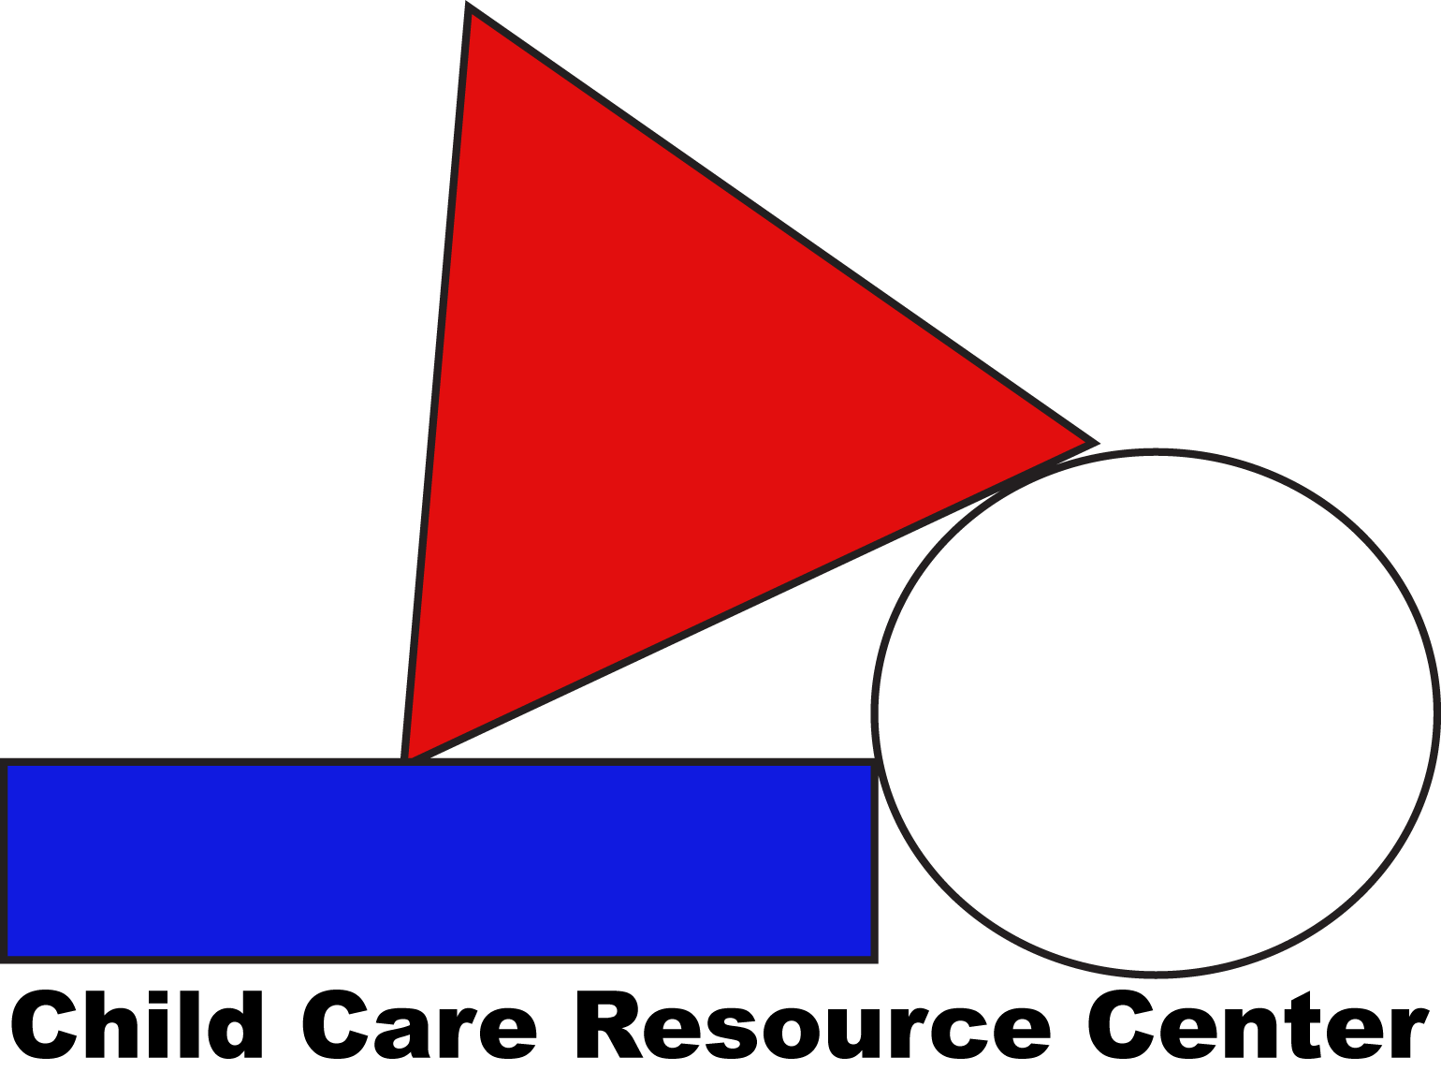Previous ECE trainings or classes taken.

